**UNIVERSITY OF BUEA**

**\*\*\*\*\*\*\*\*\*\*\*\*\*\*\*\*\*\*\*\*\*\*\*\*\*\*\*\*\*\*\*\*\*\***

**FACULTY OF ENGINEERING AND TECHNOLOGY**

**\*\*\*\*\*\*\*\*\*\*\*\*\*\*\*\*\*\*\*\*\*\*\*\*\*\*\*\*\***

**DEPARTMENT OF COMPUTER ENGINEERING**

**\*\*\*\*\*\*\*\*\*\*\*\*\*\*\*\*\*\*\*\*\*\*\*\***

**CEF 440: MOBILE PROGRAMMING**

**LEVEL 400: 2022/2023 ACADEMIC YEAR**

**Project Title:**

**DESIGN AND IMPLEMENTATION OF A PASSENGER POSITIONING SYSTEM**

**TASKS 4:**

**SYSTEM DESIGN DIAGRAMS**

**Supervisor:**

**DR NKEMENI VALERY**

**Group 8 Members:**

|  |  |
| --- | --- |
| **NGI KEVIN AYUK** | **FE20A076** |
| **NDEM LARRY NCHENY** | **FE20A071** |
| **TASHA OLIVIA** | **FE20A0112** |
| **TAGHA WILFRED** | **FE20A0122** |
| **A CLINTON MBURLI** | **FE20A010** |

# USECASE

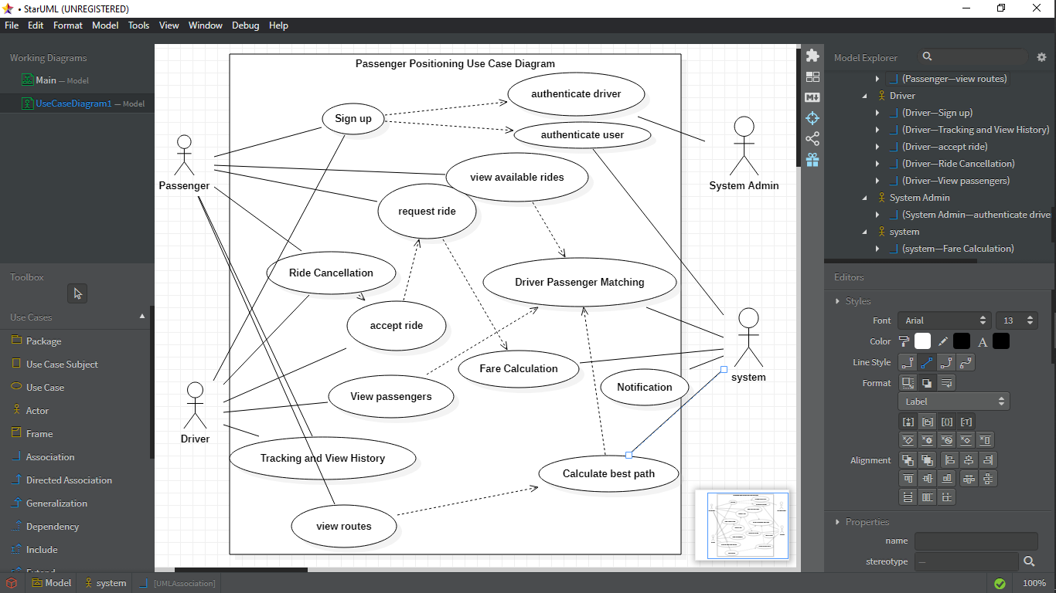

# SEQUENCE DIAGRAM

## SIGN UP

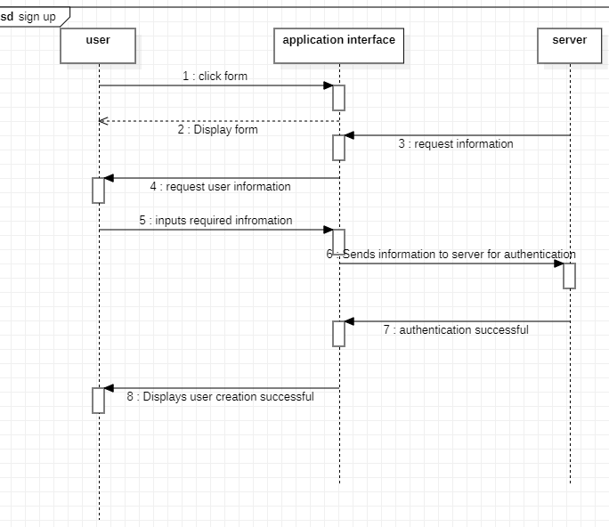

VIEW ROUTES

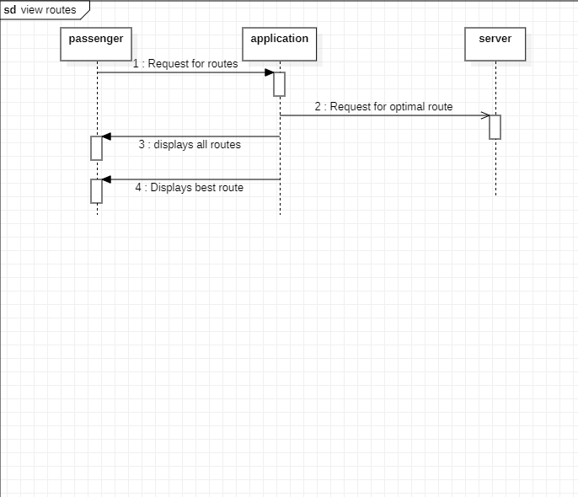

## RIDE REQUEST

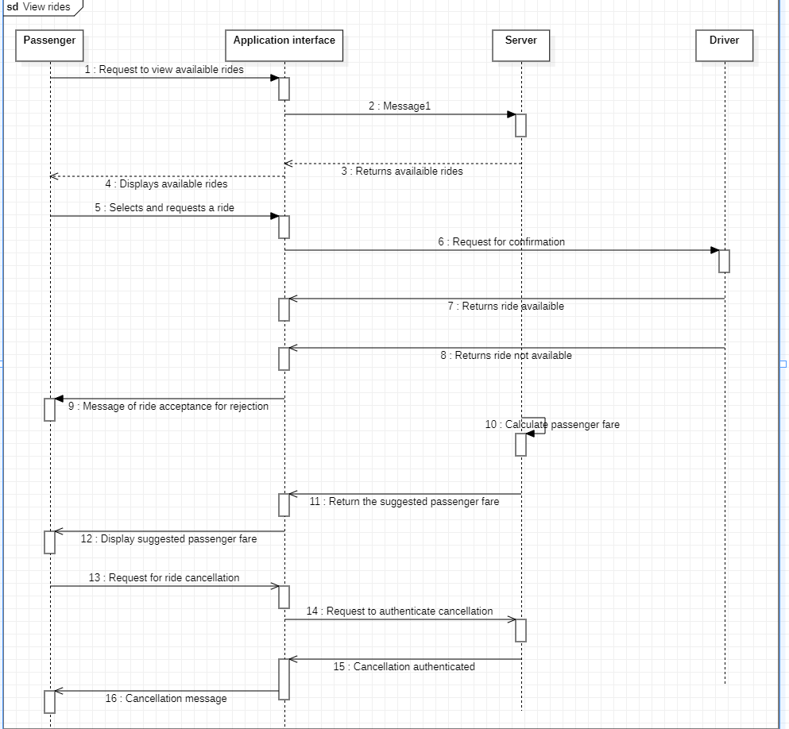

## VIEW PASSENGERS

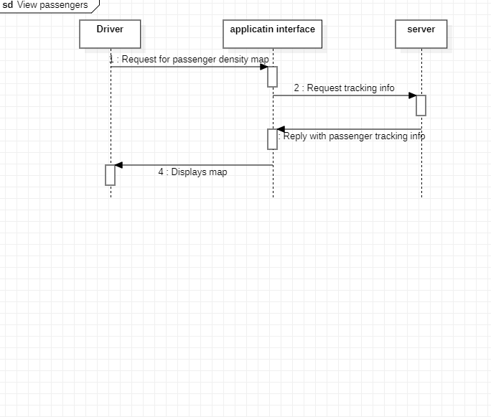

## VIEW HISTORY

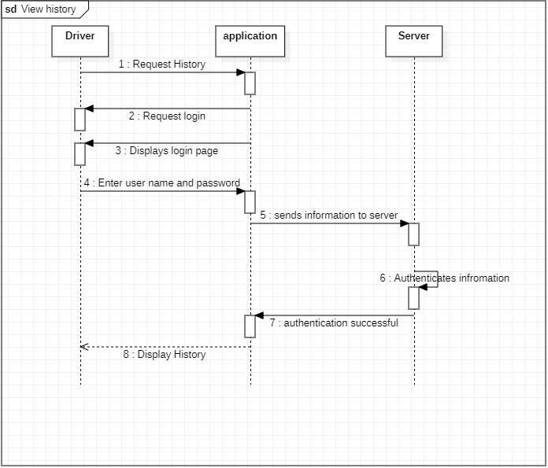

# CLASS DIAGRAM

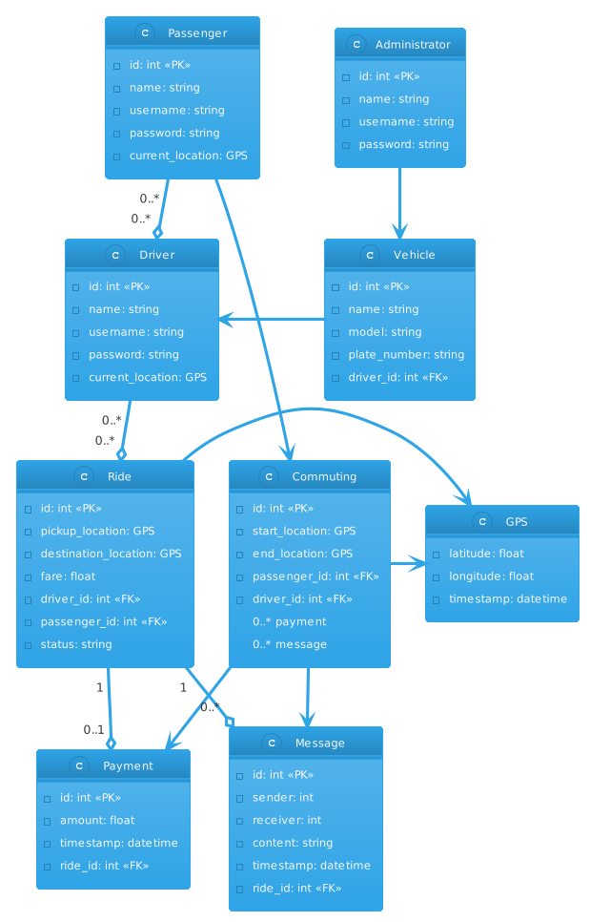

# DATA FLOW DIAGRAM

